q

Airell Rasendriya Bachtiar

airell.bachtiar@student.fontys.nl

Kasintu

Web Collection Game

Web Performance Report

Semester 3 - Individual Project

Table of Contents

**1.** **Version** 2

**2.** **Introduction** 3

2.1. Purpose 3

2.2. Definitions, Acronyms, and Abbreviations 3

**3.** **System Overview** 3

3.1. Description 3

3.2. Main User Activities 3

3.3. Project Goal 3

**4.** **Security Risk** **Error! Bookmark not defined.**

**5.** **Conclusion** 6

**6.** **References** **Error! Bookmark not defined.**

# **Version**

|  |  |  |
| --- | --- | --- |
| **Version** | **Date** | **Description** |
| 0.1 | 14-06-2022 | Web Performance Report Document |
| 1.0 | 16-06-2022 | Version 1.0 of web performance report document |

# **Introduction**

## Purpose

The purpose of this document is to show the performance of this web application.

## Definitions, Acronyms, and Abbreviations

* Gacha: A method inspired by toy vending machine where you can get a toy randomly from what the vending machine provide. Instead of toy vending machine, here it is turned into an application game where you can get an item, in this project we called a creature, randomly with a set number of chances.
* Summon or Pull: The action performed when you are getting a creature from the gacha.
* Banner: The place where you summon or pull creature. Banner contains a list of creatures in which the player can obtained and a chance or percentage of how many chances you can obtain a specific creature.

# **System Overview**

## Description

This game is called Kasintu which means bird. Kasintu is a collection-based game where player can collect as much as they want. What they will collect is a different type of birds that is real and fictional thus the meaning of Kasintu is bird, a game where you collect birds. From now on these birds will be called creature.

## Main User Activities

The main feature of this game is called a gacha system. Gacha system is where player can get a chance to receive a virtual item using in game currency. This is where player mainly get a new creature that will be release or has been released by the developer. They called this action of obtaining new creature as a summoning or pulling. In this case we will call this action as summon or summoning. As the where they summoning these creatures is called a banner. A banner contains a certain amount or all the creature available that can be obtained by the player who summoned on that banner.

For a future feature, Kasintu will also include a marketplace and breeding system. Marketplace is where player can but, sell or trade creatures from the other player. Breeding system is where player can breed their own creature to make new creature which may become rarer that the previous creature.

## Project Goal

The goal of this project is to have a game that will entertain user by collecting creatures and to collect everything the game provides. For better user experience, this game will have to has a fast user interface to make user does not need to wait long in between action or input and a secure application so that data from user cannot be tracked or stolen by a third party.

# **Web Performance**

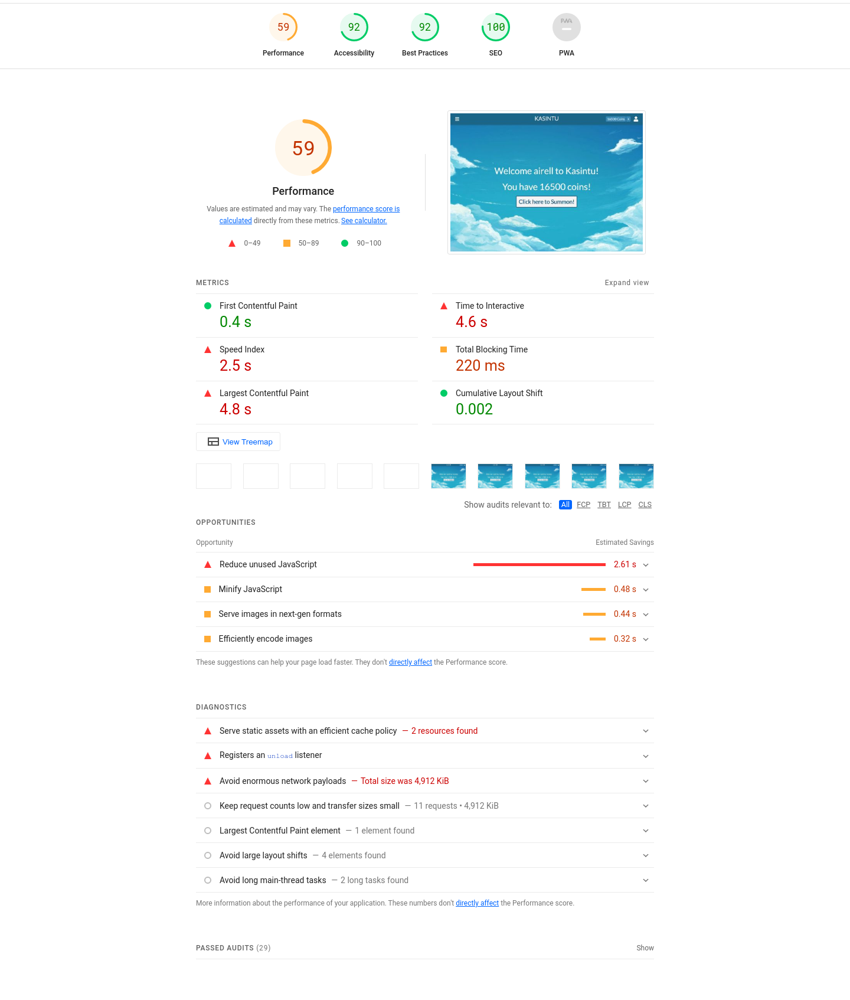Web performance report is done by using Google Lighthouse. Here’s the result:

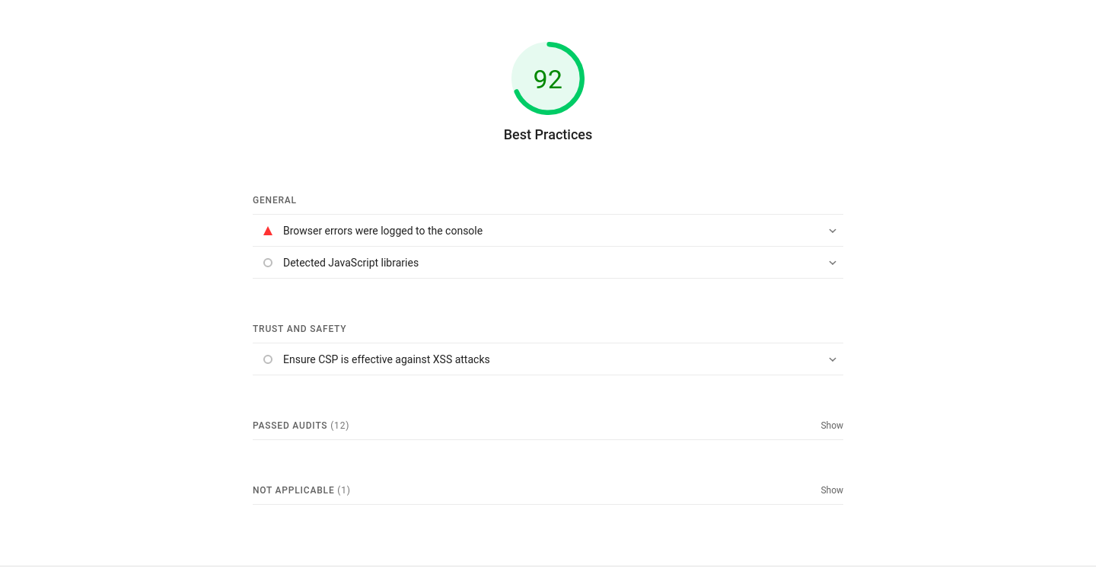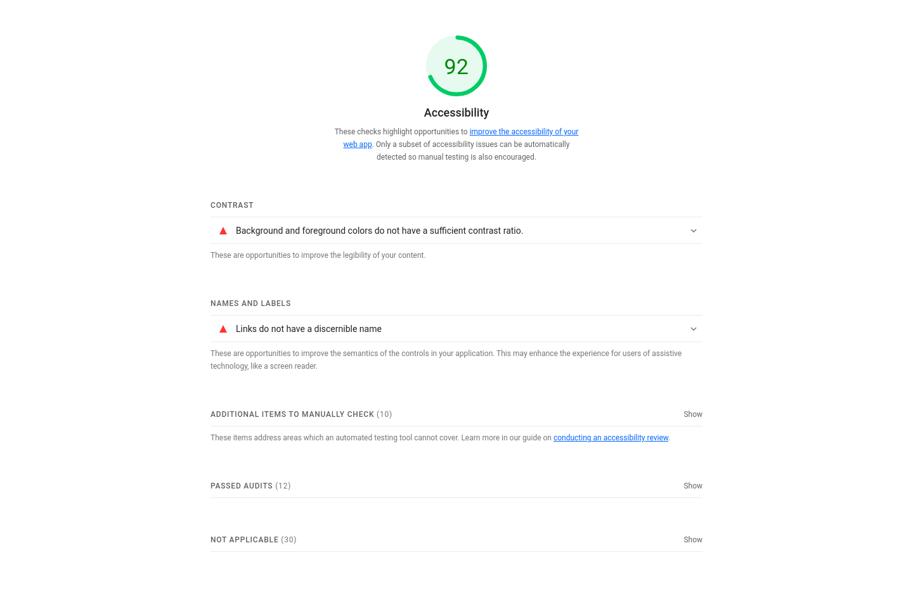

# **Improvement**

Potential improvement includes designs, more implementations that hasn’t been done from the product backlog in project plan, and performance speed. The design of the website can be improved by having more contrast colour, components placement, and better UX design. Design for different screen ratio should be implemented but due to time constraint it’s not implemented yet.